Project 2 Report Full detailed:

Project Title: Exploratory Data Analysis on an E-commerce Sales Dataset.

Executive Summary: The objective of this analysis was to explore an e-commerce sales dataset and identify meaningful business insights using Microsoft Excel. The dataset contains customer orders from 2023 to 2025. The analysis focused on descriptive statistics, customer purchasing behavior, product performance, payment preferences, referral channels, sales trends, and outlier detection.

Data Set overview: There are 1200 rows and 14 columns in data set , data set type is Ecommerce Sales record from 2023 till 2025.

Data cleaning: Cleaned and formatted data, remove 14 duplicates in CustomerID column, Fixed the date format, Remove the decimals, Filled the blank spaces and in the end insert the table. Fig 1 is messy data set and fig 2 is after data cleaning.

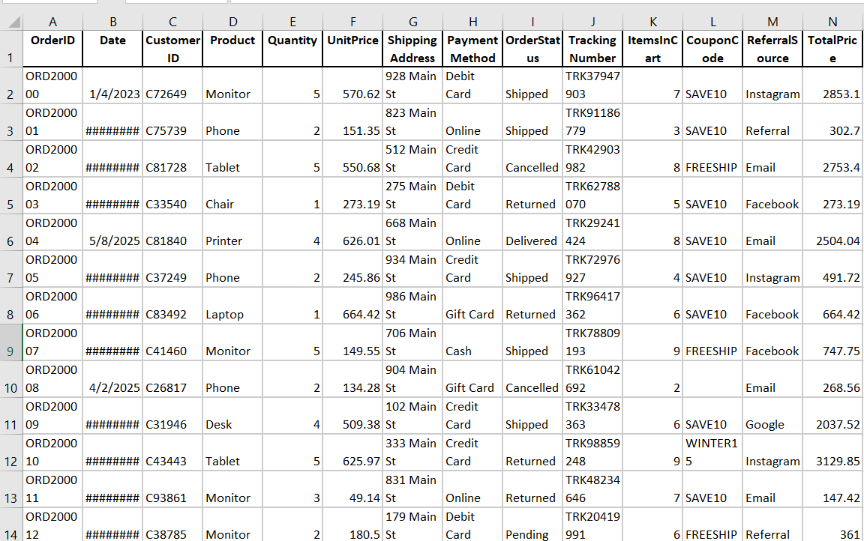
(Fig. 1)

(Fig. 2)
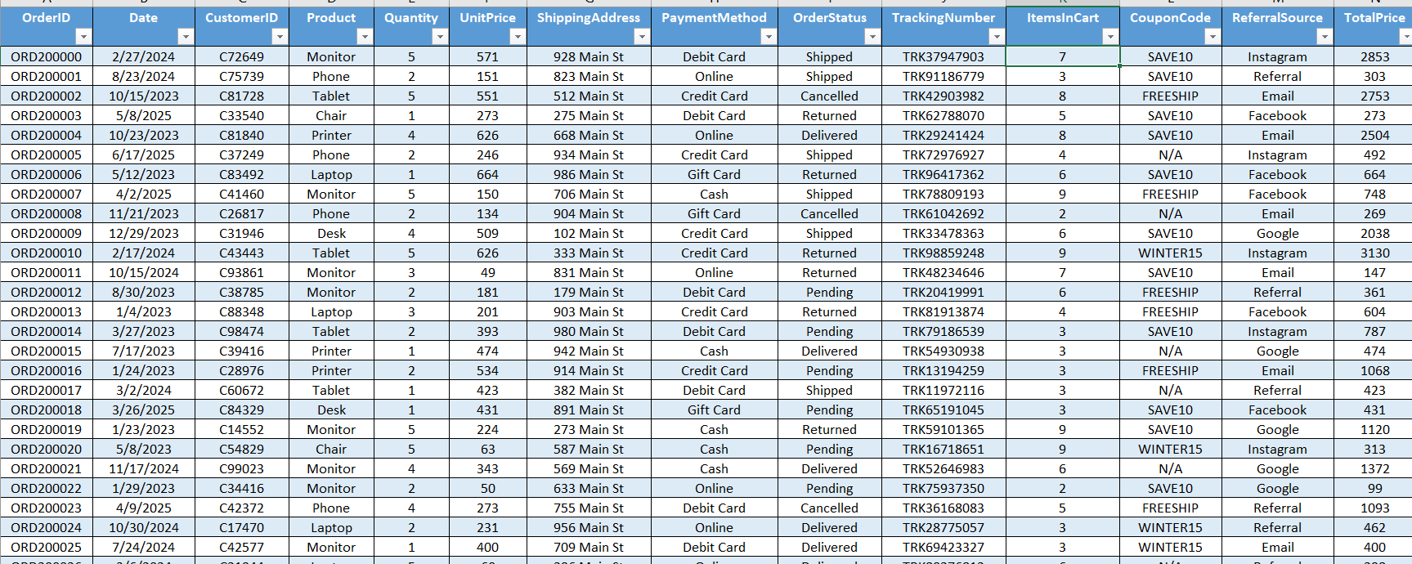

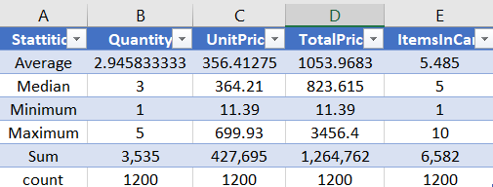
Descriptive Statistics: Create a separate sheet named it statistics using the Ecommerce sales sheet I applied basic stats , Median , Sum , Average ,Max ,Min and Count ,on columns where EDA is important.

Explanation of Statistics:
- Customers purchase approximately 3 products per order on average.
- The average order value is 1053.97.
- Unit prices vary from 11.39 to 699.93, showing a wide range of product prices.
- Customers usually add 5–6 items to their shopping cart.
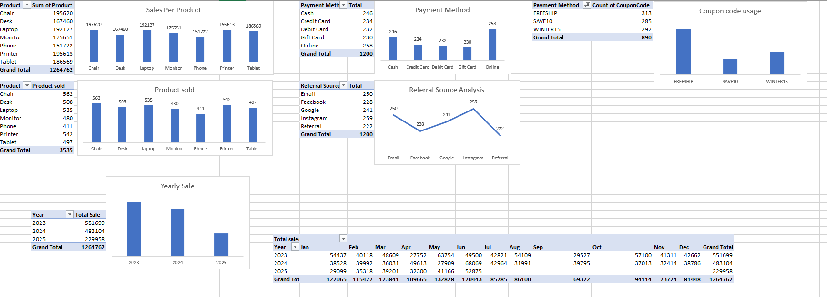
Data Analysis: Check pattern of product, payment method ,what’s the most product sold, checked which referral is most used , which year sold most and month wise sales also use charts for better visualization.

Trends:
- June has the highest month sales.
- Year 2023 has the highest sales.
- Year 2025 has most least sales. But the year 2025 data is still not completed yet.
- Month April has the least monthly sales.

NOTE: 2025 has not full records so we are not including it in our analysis.
Patterns:
- The demand per product is balanced, the company is not relied on a single product.
- All shipment methods are use in equal amount.
- Instagram generates the most referral and emails are close to it.
- Customers Slightly Prefer FREESHIP coupon.

Insights:
- Chair was the highest revenue and the most purchased product.
- Online payment is the preferred payment method.
- FREESHIP is the most frequently used coupon.
- Instagram contributes the highest number of referrals.
- June generated the highest monthly revenue.
- Customers purchase approximately 3 items per order.
- Avg order value is increased due to the higher order value.
- Customers usually add 5–6 items to their shopping cart.

Outlier Analysis:
In the data set there are small amount of orders are more.
According to my analysis there is not a outlier present in the data, the mean value or average value of an order is 1053.97 and the median of an order is 823.615 this shows that a higher order value in between is increasing the value of an average order. The higher value order are less that show they are not regular customer, they are seasonal + bulk order customers.

Conclusion: The Exploratory Data Analysis provided valuable insights into customer purchasing behavior, product performance, payment preferences, referral sources, and monthly sales trends. The dataset was clean and contained no missing or duplicate values. Product demand was balanced, while social media and promotional offers played an important role in customer acquisition. Overall, the dataset offers meaningful information that can support business decision-making.

